Q.1

Issue 1 — delivery_time_mins = 0 : 214 rows have a delivery time of zero, which is physically impossible. These are likely failed order logs, cancelled deliveries, or system errors where the timestamp wasn't recorded.
Treatment: Winsorize at the 99th percentile — cap values above a computed threshold rather than deleting, so you don't discard row-level context.

Issue 2 — order_value_Rs = ₹2,95,000 : The max is 590× the median (₹310). This single bakery order is almost certainly a bulk/catering order or a data entry mistake (extra
zeros).
Treatment: treat as missing, then impute using the median prep time per order_category (e.g., Fresh Food will have higher medians than Bakery).

Issue 3 — prep_time_mins < 0 : Negative preparation time violates domain logic. These likely result from system clock mismatches between order-placed and prep-started timestamps.
Treatment: treat as missing, then impute using the median prep time per order_category

Issue 4 — customer_rating nulls + zero values: 9,800 nulls plus some zeros — both are problematic. A rating of 0 is outside the valid 1–5 scale and should be recoded to NaN.
Treatment: convert zeros to null first, then impute missing values using the median rating segmented by order_category and city.

Q.2

What the skew indicates: When mean > median, the distribution is positively (right) skewed. A small number of very late deliveries pull the mean upward while the bulk of orders cluster around the 12–15 minute mark.

Transformation before modeling: Apply log transformation — log(delivery_time_mins + 1). This compresses the long tail, brings the distribution closer to normal, and prevents the model from being unduly influenced by extreme late-delivery outliers

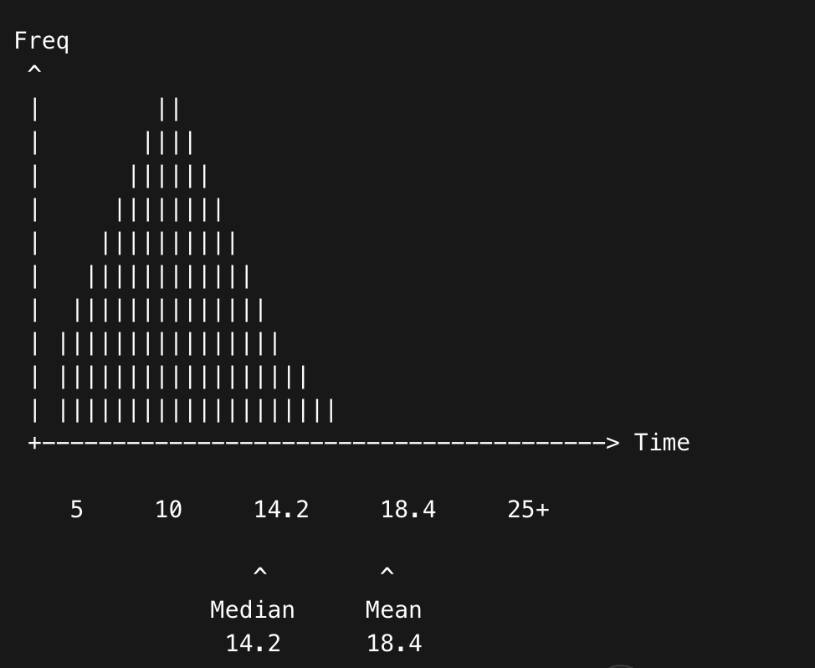

Q.3

Correlation (r = +0.74) confirms that delivery time and refunds move together, but it does not establish directionality or sole causation. Correlation is symmetric — knowing A correlates with B tells you nothing about which causes which. Even if late delivery does trigger some refunds, "eliminate delays → eliminate refunds" is wrong because:
- Other causes of refunds exist like wrong items, damaged packaging, food quality issues that would persist even after delivery speeds improve.
- The relationship may be partly spurious — both variables could be driven by a third factor.
What correlation actually indicates: A linear association between two variables. An r of +0.74 means that as delivery time increases, the probability of a refund also increases, and this relationship is strong — but it is purely statistical. It does not prove mechanism, direction, or exclusivity of cause.
Two cofounder
Rain increases both delivery time and the likelihood of damaged/late food, independently increasing refunds
order_category = Fresh Food / Bakery: Perishable categories inherently have higher refund rates (spoilage, temperature sensitivity). These orders may also take longer due to prep time

Q.4
What operational reasons could explain this bimodal pattern?
When I looked at the bimodal distribution in Mumbai and Bangalore, with one peak at 12–14 minutes and another at 28–32 minutes, my understanding is that this is happening because the data is actually mixing two very different types of orders together instead of separating them.
The first peak (12–14 mins) most likely represents orders that are being fulfilled from hubs that are very close to the customer's location, probably during non-peak hours like mid-morning or early afternoon when there is less traffic congestion and rider availability is good. These are the "ideal condition" deliveries that ZeptoFresh's 15-minute promise is built around.
The second peak (28–32 mins) in my opinion represents orders where either the rider has to travel a longer distance because the nearest hub is out of stock and order got rerouted, or the order was placed during peak hours (like 1–2 PM lunch rush or 8–9 PM dinner time) when traffic in Tier-1 cities like Mumbai is very heavy. It could also be because certain order categories like Fresh Food or Bakery have longer prep times which pushes the total time up. Rainy days could also be a contributing factor since rain_flag has r = +0.48 with delivery time.
So basically two sub-populations — fast hub + low congestion, and slow hub + high congestion — are being plotted together and creating this bimodal shape.
Why must this be addressed before building the prediction model?
This is important to fix before modeling because most algorithms like Logistic Regression or even Random Forest assume that the data comes from a single underlying population. If we train a model on this mixed data, the model will try to find a single decision boundary that works for both groups, but actually neither group will be predicted well.
Also, the mean delivery time (~18.4 mins) falls right in the valley between the two peaks, meaning the mean itself is not representative of any real order in the dataset. If we use this as our threshold for "late or not late" it will be meaningless.
What modeling mistake might occur if this is ignored?
The main mistake that can happen is that the model will underfit both sub-populations. It will predict something like 18–20 minutes for most orders, which is neither 13 minutes nor 30 minutes. So the model will systematically miss the second peak (the actual high-risk orders) because it was never trained to recognize them separately.
In simpler terms, the model will think a 28-minute delivery is "unusual" when in reality it is completely normal for a certain type of order. This leads to poor recall for the late delivery class, which is exactly what the business wants to avoid.
To fix this, I would suggest either building separate models for Tier-1 and smaller cities, or adding a hub-cluster feature that tells the model which sub-population an order belongs to.

Q.5
Based on Kavya Sharma's statement, I believe ZeptoFresh should prioritize Recall over Precision in this case.
My reasoning is as follows. If the model fails to identify an order that will actually be late (i.e., a false negative), then no action is taken and the customer receives their order after 30+ minutes. As mentioned in the business context, this significantly increases churn probability. A churned customer stops ordering from ZeptoFresh entirely, so the long-term revenue loss from one missed late delivery is much higher than just that one order's value.
On the other hand, if the model incorrectly flags an order as high-risk when it would have been fine (false positive), the company does a rider reallocation unnecessarily. This increases operational cost, but the customer still gets their order on time and is not harmed. The cost is real but it is bounded and recoverable.
So simply put:
- Missing a late delivery = customer churns = high long-term cost
- Wrong flag = extra rider cost = low short-term cost
Since the cost of a false negative is much greater than the cost of a false positive, we should tune our model to catch as many true late deliveries as possible, even if it means some unnecessary reallocations. This is exactly what high Recall does — it minimizes false negatives.
However, I also want to mention that Precision cannot be completely ignored. If our Recall is too high (say 0.98) but Precision is very low (say 0.20), then 80% of the reallocation orders flagged are unnecessary. Operations team will start losing trust in the model's alerts and might stop acting on them altogether (this is called alert fatigue). So there is a practical lower bound on Precision too.
The best approach would be to use F2-score as the evaluation metric instead of F1-score, since F2 gives twice the weightage to Recall compared to Precision, which matches our business priority here.

Q.6
Below are three new features I have engineered using only the existing columns in the dataset:
Feature 1:
total_operational_load = prep_time_mins + (rider_distance_km × 3)
I created this feature because both prep time and distance independently add to delivery time, but neither alone captures the full picture. By combining them into one feature, I am giving the model a single number that represents "how much total effort does this order require." The multiplier of 3 is a rough approximation (assuming ~3 minutes per km average speed), which can be refined later using actual historical speed data. This feature will be strongly correlated with the target variable and should be quite useful.
Feature 2:
high_stress_condition = is_weekend × rain_flag
This is an interaction feature. My thinking here is that rain alone does not cause maximum delay, and weekend alone does not cause maximum delay — but when both happen at the same time, order volumes spike AND riding conditions become dangerous, which creates the worst delivery scenario. Neither column alone would capture this combined effect, but their product creates a binary flag (0 or 1) that specifically marks these dual-stress situations. I think this will help the model identify the highest-risk time windows.
Feature 3:
value_per_item = order_value_Rs / items_count
I thought about this feature because a high value-per-item order (like a single medicine worth ₹500 or a premium bakery item) might get prioritized differently by the hub compared to a low-value multi-item grocery order. Also, higher value orders are more likely to result in a refund if they arrive late, so this feature could act as a proxy for both order complexity and customer complaint risk. It is simple to compute and does not require any external data.

